Libraries loaded successfully.
ucimlrepo unavailable (No module named 'ucimlrepo'). Falling back to direct XLS download...
Dataset loaded via direct XLS download.

Dataset shape: (30000, 24)

Column names:
['LIMIT_BAL', 'SEX', 'EDUCATION', 'MARRIAGE', 'AGE', 'PAY_0', 'PAY_2', 'PAY_3', 'PAY_4', 'PAY_5', 'PAY_6', 'BILL_AMT1', 'BILL_AMT2', 'BILL_AMT3', 'BILL_AMT4', 'BILL_AMT5', 'BILL_AMT6', 'PAY_AMT1', 'PAY_AMT2', 'PAY_AMT3', 'PAY_AMT4', 'PAY_AMT5', 'PAY_AMT6', 'default']
=== First 5 Rows ===
 | LIMIT_BAL | SEX | EDUCATION | MARRIAGE | AGE | PAY_0 | PAY_2 | PAY_3 | PAY_4 | PAY_5 | ... | BILL_AMT4 | BILL_AMT5 | BILL_AMT6 | PAY_AMT1 | PAY_AMT2 | PAY_AMT3 | PAY_AMT4 | PAY_AMT5 | PAY_AMT6 | default
ID
1 | 20000 | 2 | 2 | 1 | 24 | 2 | 2 | -1 | -1 | -2 | ... | 0 | 0 | 0 | 0 | 689 | 0 | 0 | 0 | 0 | 1
2 | 120000 | 2 | 2 | 2 | 26 | -1 | 2 | 0 | 0 | 0 | ... | 3272 | 3455 | 3261 | 0 | 1000 | 1000 | 1000 | 0 | 2000 | 1
3 | 90000 | 2 | 2 | 2 | 34 | 0 | 0 | 0 | 0 | 0 | ... | 14331 | 14948 | 15549 | 1518 | 1500 | 1000 | 1000 | 1000 | 5000 | 0
4 | 50000 | 2 | 2 | 1 | 37 | 0 | 0 | 0 | 0 | 0 | ... | 28314 | 28959 | 29547 | 2000 | 2019 | 1200 | 1100 | 1069 | 1000 | 0
5 | 50000 | 1 | 2 | 1 | 57 | -1 | 0 | -1 | 0 | 0 | ... | 20940 | 19146 | 19131 | 2000 | 36681 | 10000 | 9000 | 689 | 679 | 0
5 rows × 24 columns

=== Dataset Info ===
<class 'pandas.core.frame.DataFrame'>
Index: 30000 entries, 1 to 30000
Data columns (total 24 columns):
# Column Non-Null Count Dtype
--- ------ -------------- -----
0 LIMIT_BAL 30000 non-null int64
1 SEX 30000 non-null int64
2 EDUCATION 30000 non-null int64
3 MARRIAGE 30000 non-null int64
4 AGE 30000 non-null int64
5 PAY_0 30000 non-null int64
6 PAY_2 30000 non-null int64
7 PAY_3 30000 non-null int64
8 PAY_4 30000 non-null int64
9 PAY_5 30000 non-null int64
10 PAY_6 30000 non-null int64
11 BILL_AMT1 30000 non-null int64
12 BILL_AMT2 30000 non-null int64
13 BILL_AMT3 30000 non-null int64
14 BILL_AMT4 30000 non-null int64
15 BILL_AMT5 30000 non-null int64
16 BILL_AMT6 30000 non-null int64
17 PAY_AMT1 30000 non-null int64
18 PAY_AMT2 30000 non-null int64
19 PAY_AMT3 30000 non-null int64
20 PAY_AMT4 30000 non-null int64
21 PAY_AMT5 30000 non-null int64
22 PAY_AMT6 30000 non-null int64
23 default 30000 non-null int64
dtypes: int64(24)
memory usage: 5.7 MB

=== Target Variable Distribution ===
default
0 23364
1 6636
Name: count, dtype: int64

Default rate: 22.12%
=== Statistical Summary ===
 | LIMIT_BAL | SEX | EDUCATION | MARRIAGE | AGE | PAY_0 | PAY_2 | PAY_3 | PAY_4 | PAY_5 | ... | BILL_AMT4 | BILL_AMT5 | BILL_AMT6 | PAY_AMT1 | PAY_AMT2 | PAY_AMT3 | PAY_AMT4 | PAY_AMT5 | PAY_AMT6 | default
count | 30000.00 | 30000.00 | 30000.00 | 30000.00 | 30000.00 | 30000.00 | 30000.00 | 30000.00 | 30000.00 | 30000.00 | ... | 30000.00 | 30000.00 | 30000.00 | 30000.00 | 30000.00 | 30000.00 | 30000.00 | 30000.00 | 30000.00 | 30000.00
mean | 167484.32 | 1.60 | 1.85 | 1.55 | 35.49 | -0.02 | -0.13 | -0.17 | -0.22 | -0.27 | ... | 43262.95 | 40311.40 | 38871.76 | 5663.58 | 5921.16 | 5225.68 | 4826.08 | 4799.39 | 5215.50 | 0.22
std | 129747.66 | 0.49 | 0.79 | 0.52 | 9.22 | 1.12 | 1.20 | 1.20 | 1.17 | 1.13 | ... | 64332.86 | 60797.16 | 59554.11 | 16563.28 | 23040.87 | 17606.96 | 15666.16 | 15278.31 | 17777.47 | 0.42
min | 10000.00 | 1.00 | 0.00 | 0.00 | 21.00 | -2.00 | -2.00 | -2.00 | -2.00 | -2.00 | ... | -170000.00 | -81334.00 | -339603.00 | 0.00 | 0.00 | 0.00 | 0.00 | 0.00 | 0.00 | 0.00
25% | 50000.00 | 1.00 | 1.00 | 1.00 | 28.00 | -1.00 | -1.00 | -1.00 | -1.00 | -1.00 | ... | 2326.75 | 1763.00 | 1256.00 | 1000.00 | 833.00 | 390.00 | 296.00 | 252.50 | 117.75 | 0.00
50% | 140000.00 | 2.00 | 2.00 | 2.00 | 34.00 | 0.00 | 0.00 | 0.00 | 0.00 | 0.00 | ... | 19052.00 | 18104.50 | 17071.00 | 2100.00 | 2009.00 | 1800.00 | 1500.00 | 1500.00 | 1500.00 | 0.00
75% | 240000.00 | 2.00 | 2.00 | 2.00 | 41.00 | 0.00 | 0.00 | 0.00 | 0.00 | 0.00 | ... | 54506.00 | 50190.50 | 49198.25 | 5006.00 | 5000.00 | 4505.00 | 4013.25 | 4031.50 | 4000.00 | 0.00
max | 1000000.00 | 2.00 | 6.00 | 3.00 | 79.00 | 8.00 | 8.00 | 8.00 | 8.00 | 8.00 | ... | 891586.00 | 927171.00 | 961664.00 | 873552.00 | 1684259.00 | 896040.00 | 621000.00 | 426529.00 | 528666.00 | 1.00
8 rows × 24 columns
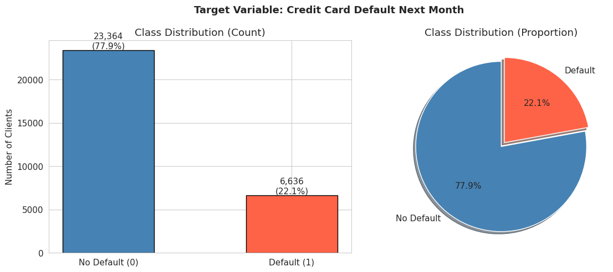
Class imbalance ratio: 3.5:1 (no default : default)
Note: Dataset is moderately imbalanced. class_weight="balanced" will be used in models.
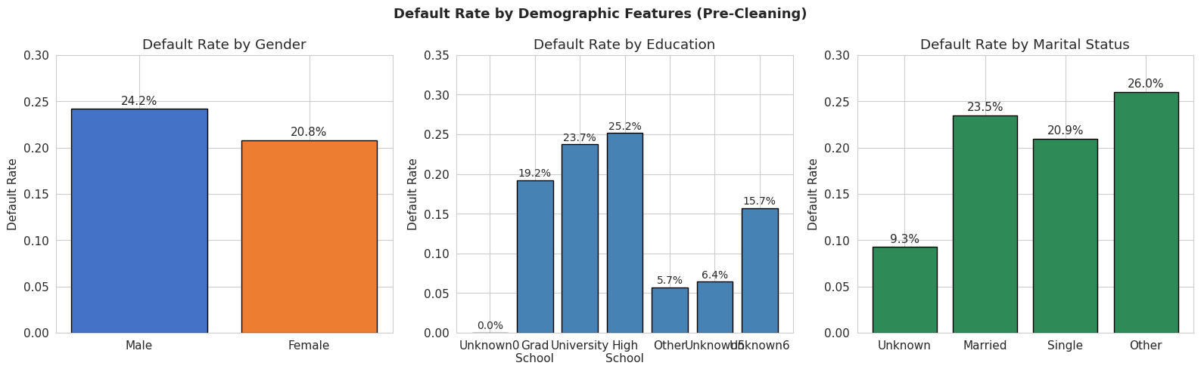
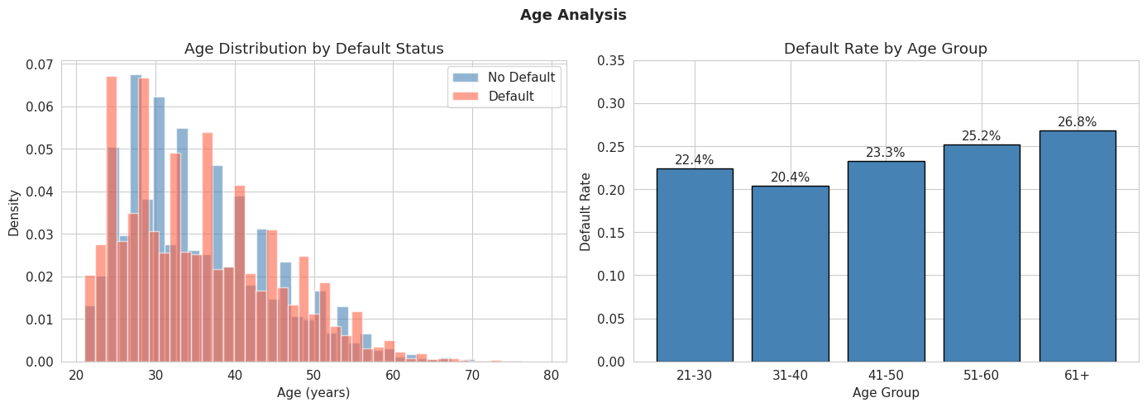
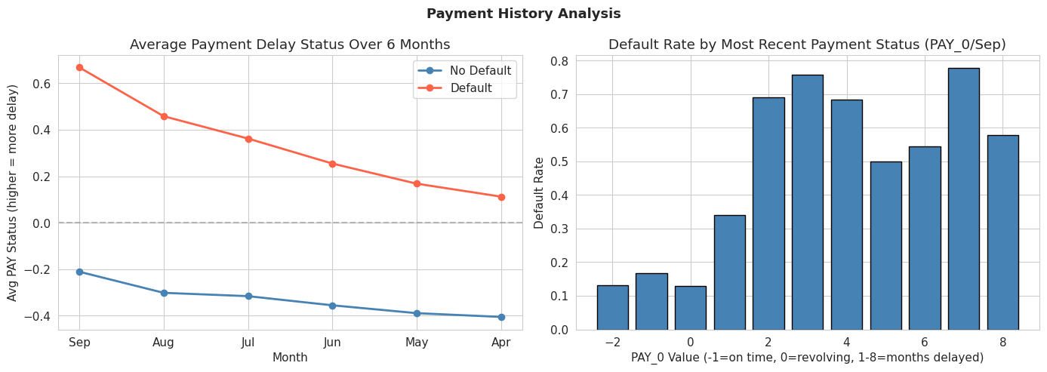
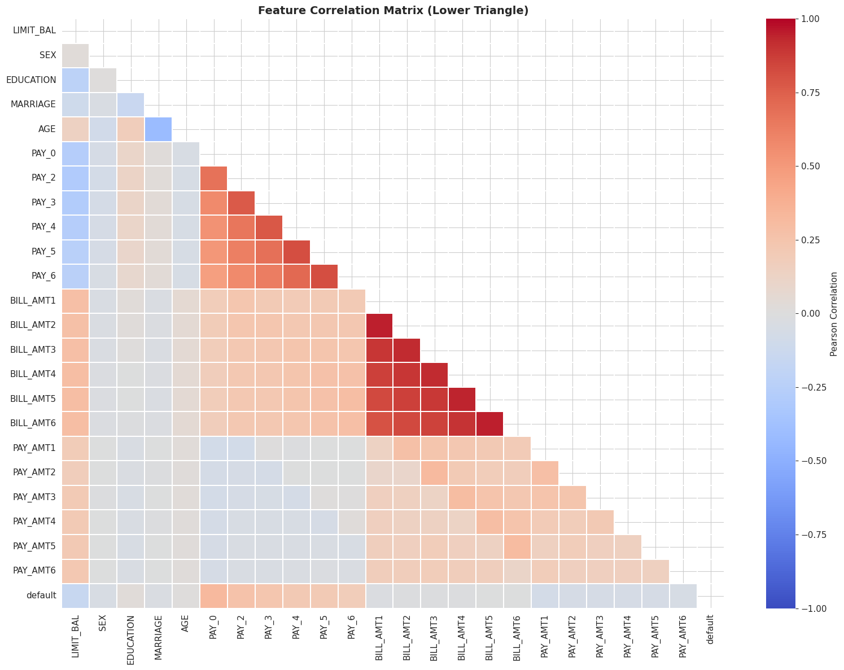
=== Top 10 Features Correlated with Default ===
|Correlation|
PAY_0 0.3248
PAY_2 0.2636
PAY_3 0.2353
PAY_4 0.2166
PAY_5 0.2041
PAY_6 0.1869
LIMIT_BAL 0.1535
PAY_AMT1 0.0729
PAY_AMT2 0.0586
PAY_AMT4 0.0568
=== Missing Values ===
Total missing: 0
No missing values found. Dataset is complete.

Duplicate rows: 35

EDUCATION values (before): [np.int64(0), np.int64(1), np.int64(2), np.int64(3), np.int64(4), np.int64(5), np.int64(6)]
Undocumented counts: 345 rows
EDUCATION values (after): [np.int64(1), np.int64(2), np.int64(3), np.int64(4)]

MARRIAGE values (before): [np.int64(0), np.int64(1), np.int64(2), np.int64(3)]
Undocumented counts: 54 rows
MARRIAGE values (after): [np.int64(1), np.int64(2), np.int64(3)]

Cleaning complete.
Feature matrix shape: (30000, 23)
Target vector shape: (30000,)

Features (23):
1. LIMIT_BAL
2. SEX
3. EDUCATION
4. MARRIAGE
5. AGE
6. PAY_0
7. PAY_2
8. PAY_3
9. PAY_4
10. PAY_5
11. PAY_6
12. BILL_AMT1
13. BILL_AMT2
14. BILL_AMT3
15. BILL_AMT4
16. BILL_AMT5
17. BILL_AMT6
18. PAY_AMT1
19. PAY_AMT2
20. PAY_AMT3
21. PAY_AMT4
22. PAY_AMT5
23. PAY_AMT6
Train size: 24,000 samples (80%)
Test size: 6,000 samples (20%)

Train default rate: 22.12%
Test default rate: 22.12%
Stratified split confirmed: rates match.

StandardScaler fit on train set.
Train mean post-scale: 0.000000 (expected ~0)
Train std post-scale: 1.000000 (expected ~1)
=== PCA Variance Summary ===
Total features: 23
Components for 90% variance: 13
Components for 95% variance: 15
Components for 99% variance: 19

Top 5 components explain: 64.17% of variance
Top 10 components explain: 83.09% of variance
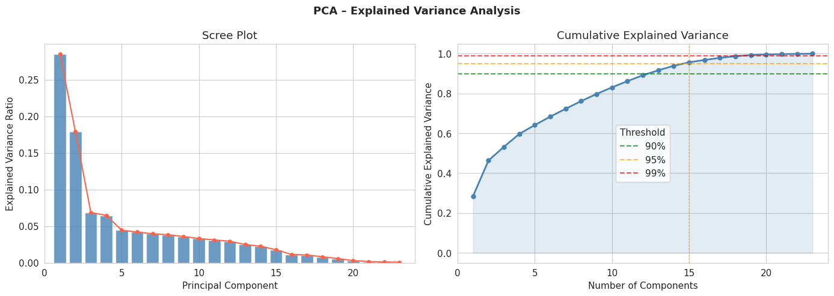
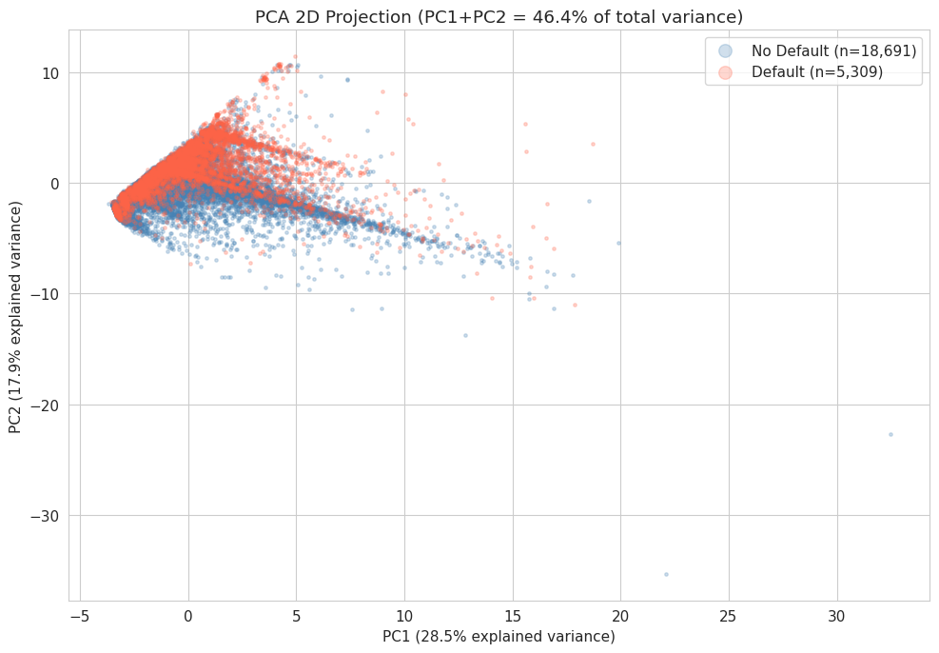
Observation: The two classes overlap significantly in the first two PCs,
suggesting linear separability is limited - non-linear models may perform better.
evaluate_model() helper defined.

=======================================================
MODEL: Logistic Regression
=======================================================
precision recall f1-score support

No Default 0.87 0.70 0.77 4673
Default 0.37 0.62 0.46 1327

accuracy 0.68 6000
macro avg 0.62 0.66 0.62 6000
weighted avg 0.76 0.68 0.70 6000

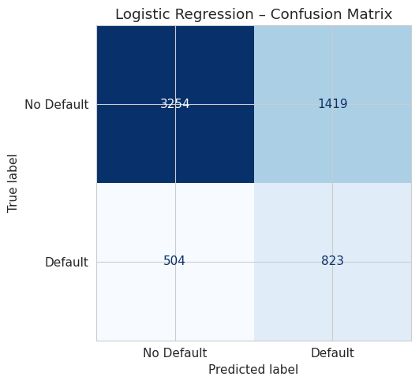
5-Fold CV ROC-AUC: 0.7264 ± 0.0106

=======================================================
MODEL: Naive Bayes
=======================================================
precision recall f1-score support

No Default 0.86 0.81 0.84 4673
Default 0.45 0.55 0.50 1327

accuracy 0.75 6000
macro avg 0.66 0.68 0.67 6000
weighted avg 0.77 0.75 0.76 6000

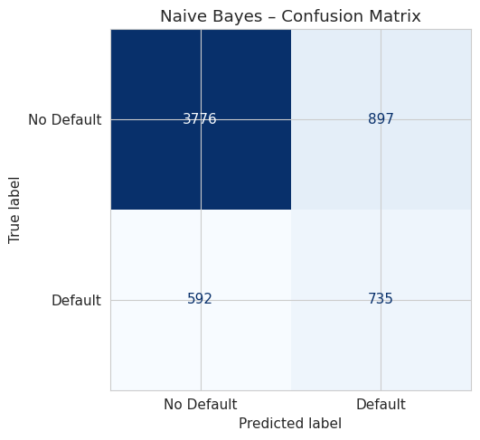
5-Fold CV ROC-AUC: 0.7365 ± 0.0102

=======================================================
MODEL: Decision Tree
=======================================================
precision recall f1-score support

No Default 0.87 0.84 0.85 4673
Default 0.49 0.55 0.52 1327

accuracy 0.77 6000
macro avg 0.68 0.69 0.68 6000
weighted avg 0.78 0.77 0.78 6000

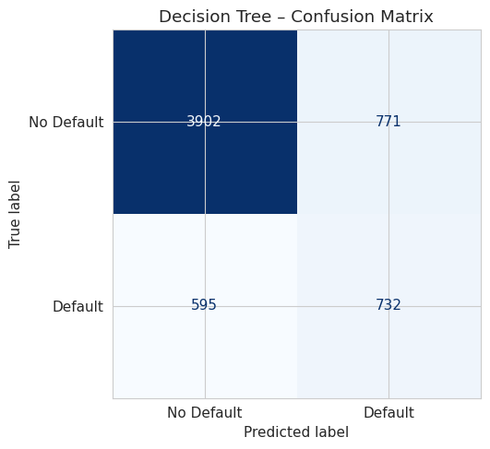
5-Fold CV ROC-AUC: 0.7577 ± 0.0067
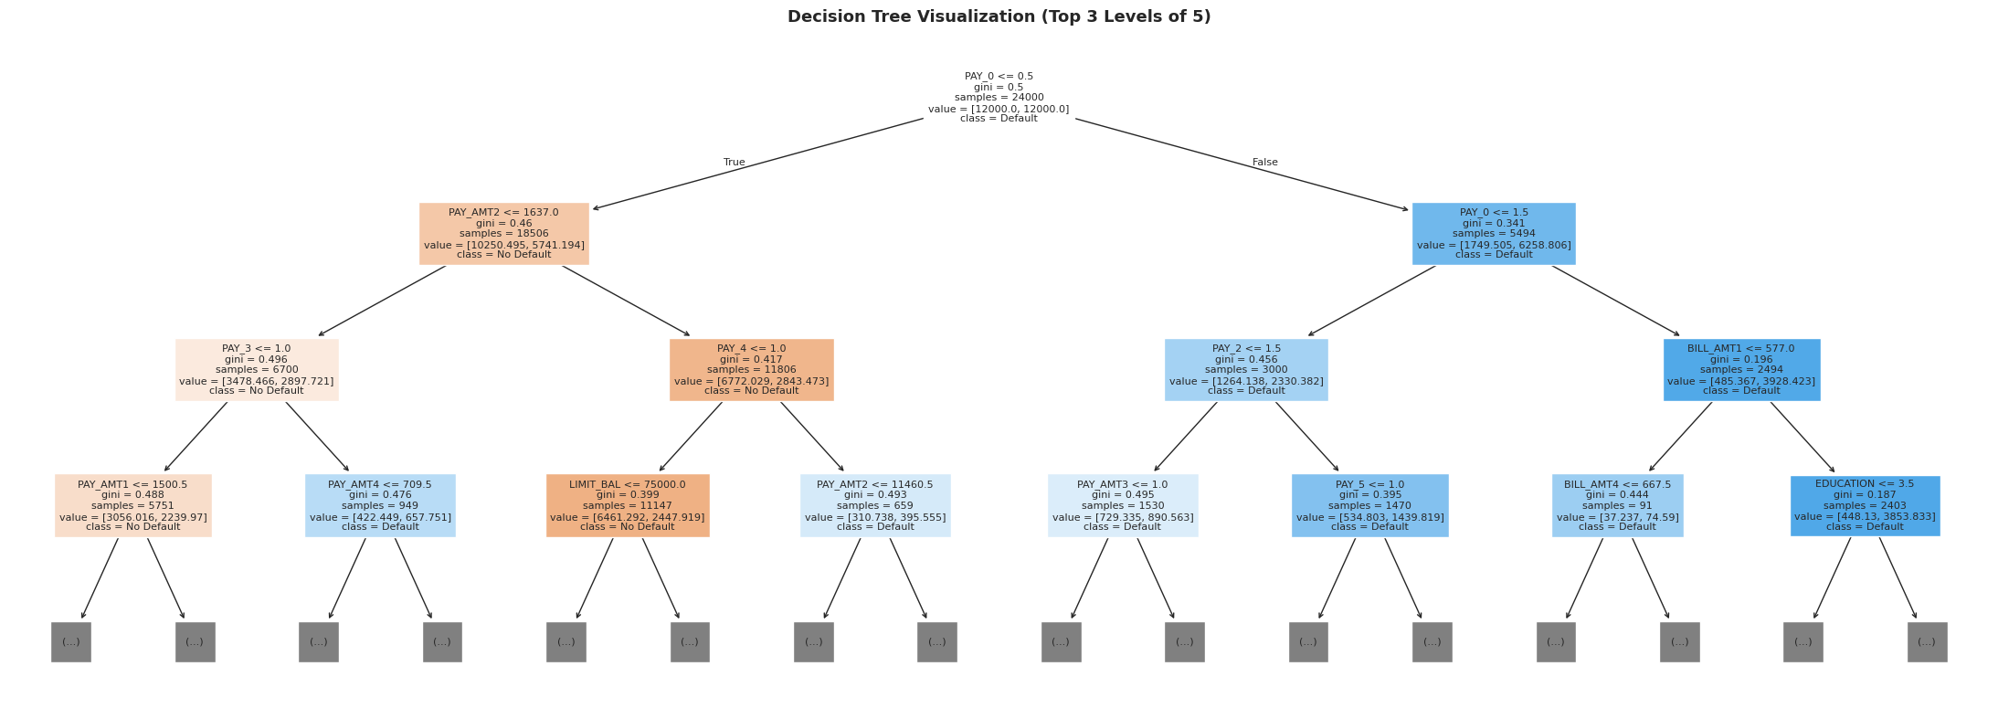
=== Model Performance Comparison ===
 | Accuracy | Precision | Recall | F1-Score | ROC-AUC | CV_AUC_Mean | CV_AUC_Std
Model
Logistic Regression | 0.6795 | 0.3671 | 0.6202 | 0.4612 | 0.7084 | 0.7264 | 0.0106
Naive Bayes | 0.7518 | 0.4504 | 0.5539 | 0.4968 | 0.7248 | 0.7365 | 0.0102
Decision Tree | 0.7723 | 0.4870 | 0.5516 | 0.5173 | 0.7589 | 0.7577 | 0.0067

Best F1-Score : Decision Tree (0.5173)
Best ROC-AUC : Decision Tree (0.7589)
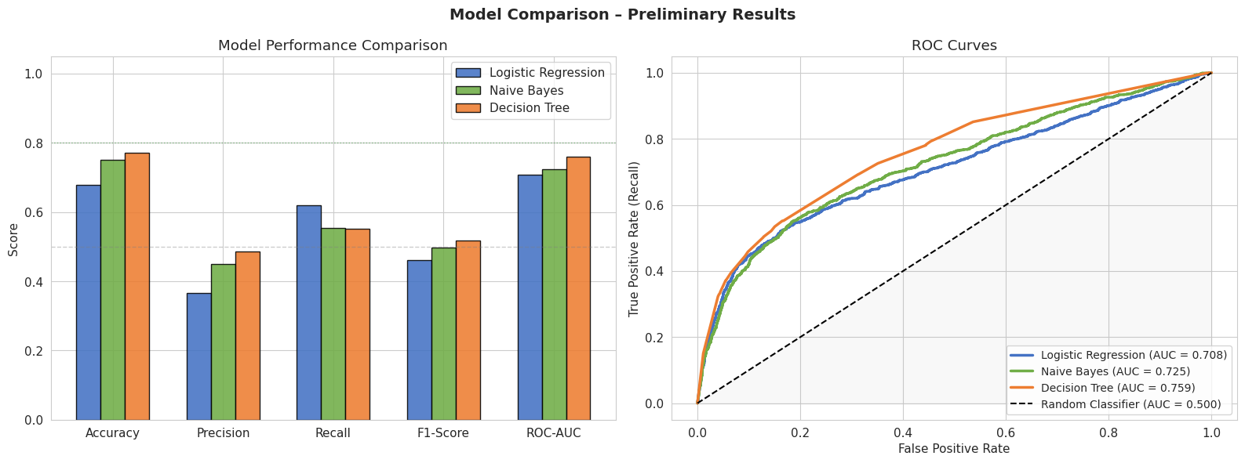
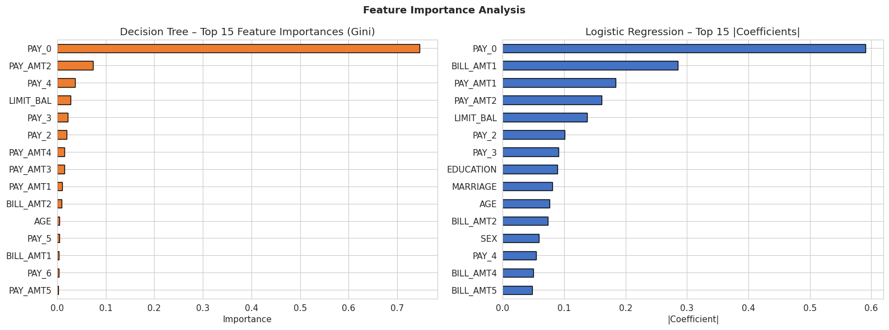
=== Top 10 Features: Decision Tree (Gini Importance) ===
PAY_0 0.7461
PAY_AMT2 0.0737
PAY_4 0.0372
LIMIT_BAL 0.0276
PAY_3 0.0225
PAY_2 0.0200
PAY_AMT4 0.0150
PAY_AMT3 0.0148
PAY_AMT1 0.0105
BILL_AMT2 0.0089

=== Top 10 Features: Logistic Regression (|Coefficient|) ===
PAY_0 0.5903
BILL_AMT1 0.2853
PAY_AMT1 0.1843
PAY_AMT2 0.1612
LIMIT_BAL 0.1369
PAY_2 0.1010
PAY_3 0.0909
EDUCATION 0.0887
MARRIAGE 0.0809
AGE 0.0761
=================================================================
MILESTONE 2 – PRELIMINARY RESULTS SUMMARY
=================================================================
 | Accuracy | Recall | F1-Score | ROC-AUC
Model
Logistic Regression | 0.6795 | 0.6202 | 0.4612 | 0.7084
Naive Bayes | 0.7518 | 0.5539 | 0.4968 | 0.7248
Decision Tree | 0.7723 | 0.5516 | 0.5173 | 0.7589

Key Observations:
1. PAY_0 (most recent payment status) is the strongest predictor
2. Payment history features (PAY_0 - PAY_6) dominate feature importance
3. PCA shows significant class overlap in first 2 components
4. Class imbalance (78/22) requires balanced weighting or resampling

Next Steps (for final report):
1. Hyperparameter tuning via GridSearchCV
2. Address class imbalance with SMOTE (imblearn)
3. Consider ensemble models (Random Forest, Gradient Boosting)
4. Feature engineering: payment utilization ratios (PAY_AMT/BILL_AMT)
5. Final model selection with comprehensive analysis

